Our Local environment Project 2023

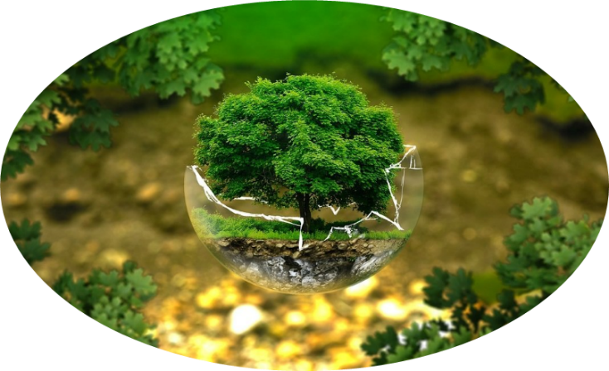

This term we are carrying out a local study, looking at the geography and history of the place where we live. Your challenge is to carry out your own mini study. It can take any format; for example, you might carry out a bird survey of all the birds you see out of your window over a period of time, trying to identify them. Or you might look for fossils and different stones in your garden. You could research the history of the house that you live in…or find out about famous people who have lived and worked near you. Remember you can visit the Heritage Centre and ask for help it is open until October…so don’t leave it too late.

Your project can be written, or make a model, or write a playscript for others to act out. It could be a power point, or in the form of a poem. You might gather together different artefacts and set up a mini museum. The choice is yours…have fun. They must be in by **MONDAY 11th December.**